Terraria equipment databAse

IT&C 350 database design project

Winter 2024

Sam Swindler

Ethan Beere

Matthew Gregg

Spencer Baird

Table of Contents

Project Overview 3

App Requirements 4

Database Requirements 5

Business Rules 6

Database Documentation 7

es 8

# Project Overview

## Project objective Statement

Create an equipment preparation system for Terraria players that enables users to discover and create the best combination of equipment for their current in-game situation.

## Project Stakeholders

Who are the Stakeholders?

* Terraria players.
* Our creation team.

Who is going to be maintaining the site?

* We, the aforementioned four horsemen of this project, are the maintainers of the site.

A shortened interview with Mr. Sam, a Terraria expert.

Q: Why do you like Terraria?

A: There’s lots of bosses and lot of fun equipment. You can kill things with yo-yo's!

Q: What is the hardest thing about Terraria?

A: Acquiring stuff and getting ready for fights. Need to understand how to get ready.

Q: What would you envision an app of this type could do for you?

A: It could help me understand my options at where I am in the game.

Q: Limitations of current systems?

A: Terraria wiki exists, but you have to browse the wiki. Stats aren’t shown in a concise form.

Q: What features would you like to see?

A: Understand boss difficulties, and crafting trees.

# App Requirements

## Functional Requirements

Home Page Functionality

* Users can see a list of all items available for them to acquire and use under the condition that they have logged in and created a character profile.
* The list of available items changes based on the information provided by users about their Terraria Character.
* Users can view individual items with statistics about each item.
* Users can select an item to add to their list of equipped items.

Character Page Functionality

* Users can record what bosses their character has defeated so far.
* Users can record whether they have entered hard-mode or not.
* Users can record what biomes/regions they have discovered in their world so far.
* Users can see the current character statistics with the items they have equipped.

User page Functionality

* Users can create and select characters.
* Users can change their password.

## non-Functional Requirements

Security

* Website protects against XSS.
* Website inputs will protect against SQL injections.
* Fail2ban (wish list)

Availability

* 95% uptime and availability.

Usability

* Mobile/Desktop application. (wish list)
* Dark mode.

# Database Requirements

## ER Diagram Images

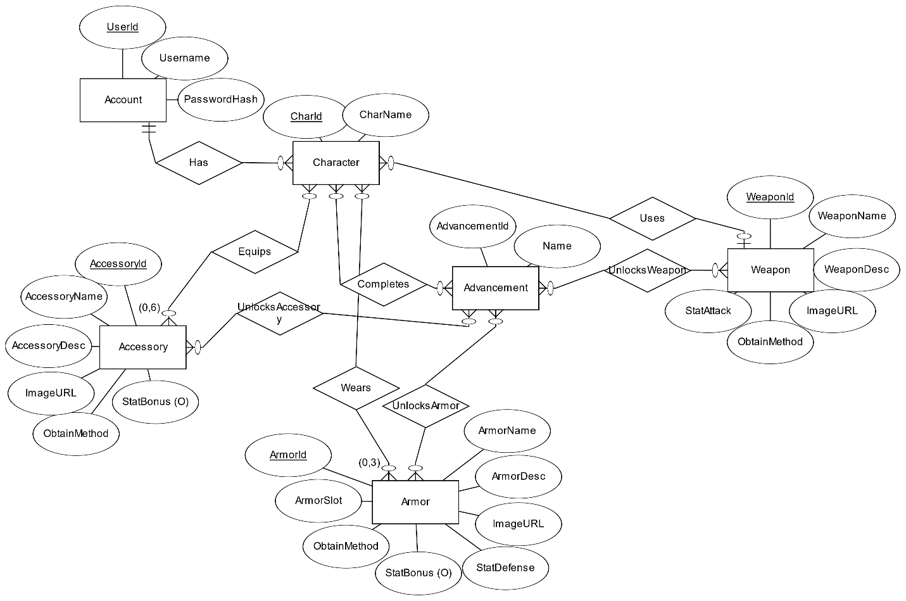

## Schema Diagram

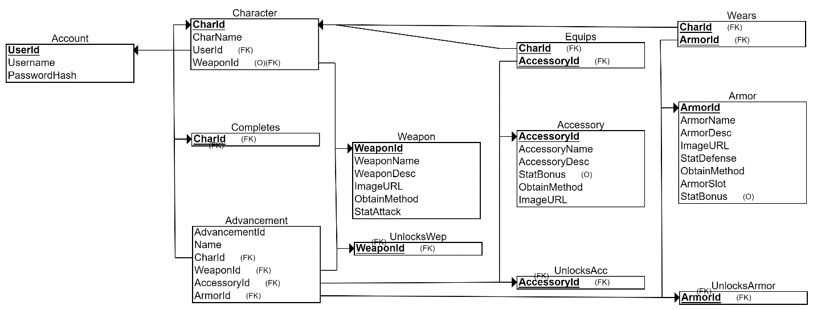

## Business Rules

* Users can create up to 25 characters.
* Newly created characters have no items assigned to them.
* Characters can equip, at maximum, 1 weapon, 3 armor pieces (head, chest plate, boots), and 6 pieces of equipment.
* Users can have zero or one characters selected for viewing relevant and equipped items.
* The list of items cannot be changed from the front end and will be managed directly in the database by site administrators when needed.
* Usernames can only contain letters and numbers (no special characters).
* Attempts to equip more items than is permitted will not replace prior equipped items (operation will produce an error instead).
* If a user has no character selected, they are unable to equip any items.
* Users can have zero or more advancements selected when filtering data output.

# Database Documentation

# API Documentation

# Front-End Documentation

# Appendix 1: Low-fidelity paper prototypes

|  |
| --- |
| Login Screen |
| Account controls screen |
| Character Information Screen |
| Item Details Screen |
| Home page showing available items |

# Appendix 2: High-Fidelity Paper Prototypes

[images]